Biological Membranes and Transport

Membranes define the external boundaries of cells and regulate the molecular traffic across that boundary; in eukaryotic cells, they divide the internal space into discrete compartments to segregate processes and components.
Membranes are flexible, self-sealing, and selectively permeable to polar solutes. Their flexibility permits the shape changes that accompany cell growth and movement (such as amoeboid movement). With their ability to break and reseal, two membranes can fuse, as in exocytosis, or a single membrane-enclosed compartment can undergo fission to yield two sealed compartments, as in endocytosis or cell division, without creating gross leaks through cellular surfaces. Because membranes are selectively permeable, they retain certain compounds and ions within cells and within specific cellular compartments, while excluding others.
Membranes are not merely passive barriers. Membranes consist of just two layers of molecules and are therefore very thin; they are essentially two-dimensional. Because intermolecular collisions are far more probable in this two-dimensional space than in three-dimensional space, the efficiency of enzyme-catalyzed processes organized within membranes is vastly increased.

The Molecular Constituents of Membranes
Molecular components of membranes include proteins and polar lipids, which account for almost all the mass of biological membranes, and carbohydrate present as part of glycoproteins and glycolipids.
Each type of membrane has characteristic lipids and proteins.
The relative proportions of protein and lipid vary with the type of membrane, reflecting the diversity of biological roles (as shown in table 12-1, see below). For example, plasma membranes of bacteria and the membranes of mitochondria and chloroplasts, in which many enzyme-catalyzed processes take place, contain more protein than lipid.
Each kingdom, each species, each tissue or cell type, and the organelles of each cell type have a characteristic set of membrane lipids. The protein composition of membranes from different sources varies even more widely than their lipid composition, reflecting functional specialization.
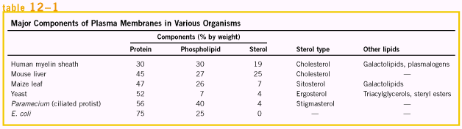
Some membrane proteins are covalently linked to complex arrays of carbohydrate.
The sugar moieties of surface glycoproteins influence the folding of the protein, as well as its stability and intracellular destination, and they play a significant role in the specific binding of ligands to glycoproteins surface receptors. Unlike plasma membranes, intracellular membranes such as those of mitochondria and chloroplasts rarely contain covalently bound carbohydrates.  Some membrane proteins are covalently attached to one or more lipids, which serve as hydrophobic anchors that hold the proteins to the membrane. | 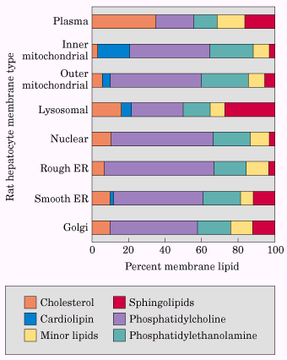  Lipid composition of the plasma membrane and organelle membranes of a rat hepatocyte.

The Supramolecular Architecture of Membranes
All biological membranes share certain fundamental properties. They are impermeable to most polar or charged solutes, but permeable to nonpolar compounds; they are 5 to 8 nm (50 to 80 Å) thick and appear trilaminar when viewed in cross section with the electron microscope. Fluid mosaic model is a model to represents the constitution and architecture of biological membranes, where phospholipids and sterols form a lipid bilayer in which the nonpolar regions of the lipid molecules face each other at the core of the bilayer and their polar head groups face outward. In this bilayer sheet, proteins are embedded at irregular intervals, held by hydrophobic interactions between the membrane lipids and hydrophobic domains in the proteins. Some proteins protrude from only one side of the membrane; others have domains exposed on both sides. The orientation of proteins in the bilayer is asymmetric giving the membrane “sidedness”; the protein domains exposed on one side of the bilayer are different from those exposed on the other side, reflecting functional asymmetry. The membrane mosaic is fluid because most of the interactions among its components are noncovalent, leaving individual lipid and protein molecules free to move laterally in the plane of the membrane.
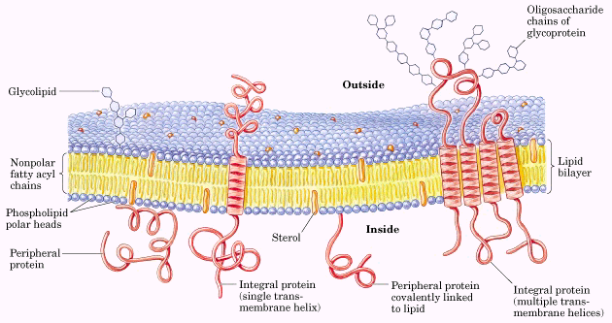
A lipid bilayer is the basic structural element of membranes
Glycerophospholipids, sphingolipids, and sterols are virtually insoluble in water. When they meet with water, they aggregate to form micelle, bilayer or liposome structures, why? (see p392, 3rd paragraph)
Depending on the precise conditions and the nature of the lipids, three types of lipid aggregates can form when amphipathic lipids are mixed with water. Micelles are spherical structures containing a few dozen to a few thousand molecules arranged with their hydrophobic regions aggregated in the interior, excluding water, and their hydrophilic head groups at the surface, in contact with water. Micelle formation is favored when the cross-sectional area of the head group is greater than that of the acyl side chain(s).
A second type of lipid aggregate in water is the bilayer, in which two lipid monolayers form a two-dimensional sheet. Bilayer formation occurs most readily when the cross-sectional areas of the head group and acyl side chain(s) are similar, as in glycerophospholipids and sphingolipids. The hydrophobic portions in each monolayer, excluded from water, interact with each other. The hydrophilic head groups interact with water at each surface of the bilayer.
The third type of aggregate is on the basis of bilayer, which folds back on itself to form a hollow sphere called a vesicle of liposome (why?). By forming vesicles, bilayers lose their hydrophobic edge regions, achieving maximal stability in their aqueous environment.  These three types of lipids aggregates are shown right. | 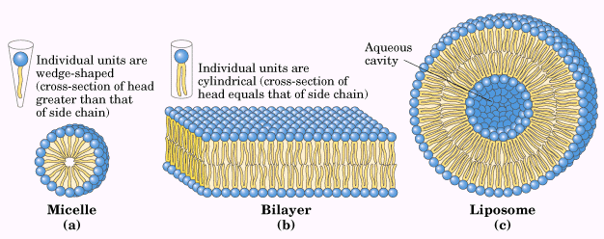

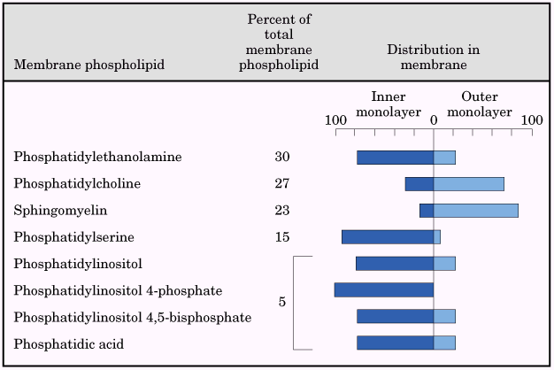 | All evidence indicates that biological membranes are constructed of lipid bilayers (how?). Membranes lipids are asymmetrically distributed between the two monolayers of the bilayer, but not absolute. The asymmetric distribution of phospholipids between the inner and outer monolayers of the erythrocyte plasma membrane are shown left.

Membrane lipids are in constant motion
Although the lipid bilayer structure itself is stable, the individual phospholipid and sterol molecules have great freedom of motion within the plane of the membrane. The interior of the bilayer is fluid; individual hydrocarbon chains of fatty acids are in constant motion produced by rotation about the carbon-carbon bonds of the long acyl side chains. The degree of fluidity depends on lipid composition and temperature. The transition temperature is the temperature above which the paracrystalline solid changes to fluid, the transition temperature is characteristic for each membrane and depends on its lipid composition.
The sterol content of a membrane is another important determinant of transition temperature (why? 2nd paragraph on page 394). Sterols therefore tend to moderate the extremes of solidity and fluidity of membranes.
Cells regulate their lipid composition to achieve a constant membrane fluidity under various growth conditions (see table 12-2, right).  A second type of lipid motion involves not merely the flexing of fatty acyl chains but the movement of an entire lipid molecule relative to its neighbors. The combination of acyl chain flexing and lateral diffusion produces a membrane bilayer with the properties of a liquid crystal: a high degree of regularity in one dimension (perpendicular to the bilayer) and great mobility in the other (the plane of the bilayer). | 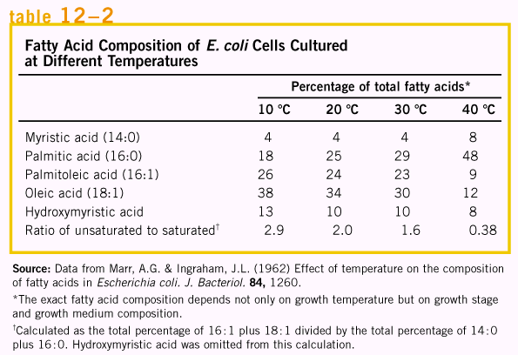

A third kind of lipid motion, much less probable than conformational motion or lateral diffusion, is transbilayer or “flip-flop” diffusion of a molecule from one face of the bilayer to the other. A family of proteins (flippases) facilitates flip-flop diffusion, providing a transmembrane path that is energetically more favorable than uncatalyzed diffusion.

Some membrane proteins span the lipid bilayer
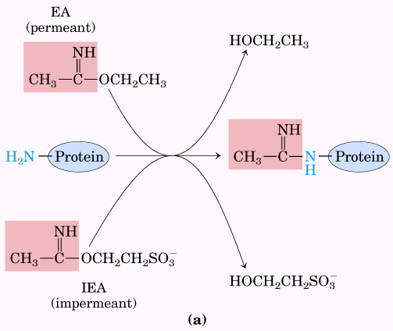  Experiments to determine the transmembrane arrangement of membrane proteins. | 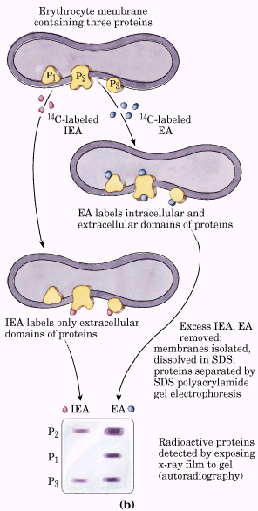 | The individual protein molecules and multiprotein complexes of biological membranes can be visualized by electron microscopy of the freeze-fractured membranes.  Some proteins span the full thickness of the bilayer, protrude from both inner and outer membrane surfaces, which conduct solutes or signals across the membrane; the others appear on only one face of the membrane.  Membrane protein localization has also been investigated with reagents that react with protein side chains but cannot cross membranes (see examples shown left). If a membrane protein in an intact erythrocyte reacts with a membrane-impermeant reagent, it must have at least one domain exposed on the outer (extracellular) face of the membrane (why? Page 397).

One further fact may be deduced from the results of the experiments with glycophorin: its disposition in the membrane is asymmetric. Similar studies of other membrane proteins show that each has a specific orientation in the bilayer and that proteins reorient by flip-flop diffusion very slowly, if at all. Furthermore, glycoproteins of the plasma membrane are invariably situated with their sugar residues on the outer surface of the cell. The asymmetric arrangement of membrane proteins results in functional asymmetry. All the molecules of a given ion pump, for example, have the same orientation in the membrane and therefore pump in the same direction.

Peripheral membrane proteins are easily solubilized
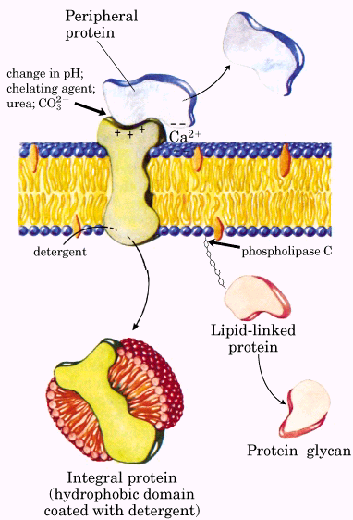  Peripheral and integral proteins | Membrane proteins may be divided into two operational groups (see left). Integral (intrinsic) proteins are very firmly associated with the membrane, removable only by agents that interfere with hydrophobic interactions, such as detergents, organic solvents, or denaturants. Peripheral (extrinsic) proteins associate with the membrane through electrostatic interactions and hydrogen bonding with the hydrophilic domains of integral proteins and with the polar head groups of membrane lipids. They can be released by relatively mild treatments that interfere with electrostatic interactions or break hydrogen bonds. Peripheral proteins may serve as regulators of membrane-bound enzymes or may limit the mobility of integral proteins by tethering them to intracellular structures.

Covalently attached lipids anchor some peripheral membrane proteins
Some membrane proteins contain one or more covalently linked lipids of several types: long-chain fatty acids, isoprenoids, or glycosylated derivatives of phosphatidylinositol, GPI. The attached lipid provides a hydrophobic anchor, which inserts into the lipid bilayer and holds the protein at the membrane surface. The strength of the hydrophobic interaction between a bilayer and a single hydrocarbon chain linked to a protein is barely enough to anchor the protein securely. Other interactions, such as ionic attractions between positively charged Lys residues in the protein and negatively charged lipid head groups, probably stabilize the attachment.
Beyond merely anchoring a protein to the membrane, the attached lipid may have a more specific role. In the plasma membrane, proteins with GPI anchors are exclusively on the outer (extracellular) face, whereas other types of lipid-linked proteins are found exclusively on the inner (cytosolic) face.

Integral proteins are held in the membrane by hydrophobic interactions with lipids
The firm attachment of integral proteins to membranes is the result of hydrophobic interactions between membrane lipids and hydrophobic domains of the protein. Some proteins have a single hydrophobic sequence in the middle (glycophorin, for example) or at the amino or carboxyl terminus. Others have multiple hydrophobic sequences, each of which, when in the α-helical conformation, is long enough to span the lipid bilayer.  For known proteins of the plasma membrane, the spatial relationships of protein domains to the lipid bilayer fall into six categories. Type I and II have only one transmembrane helix; the amino terminal domain is outside the cell in type I proteins and inside in type II. Type III proteins have multiple transmembrane helices in a single polypeptide. In type IV proteins, transmembrane domains of several different polypeptides assemble to form a channel through the membrane. Type V proteins are held to the bilayer primarily by covalently linked lipids, and type VI proteins have both transmembrane helices and lipid (GPI) anchors. (see picture on the right). | 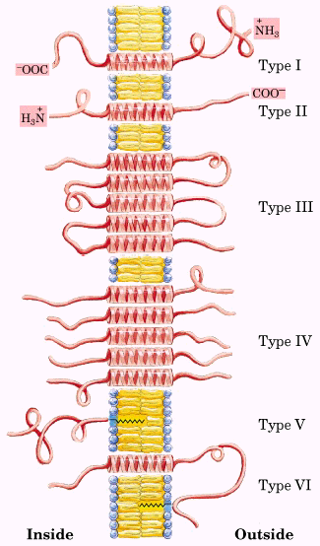

The topology of an integral membrane protein can sometimes be predicted from its sequence
Determining the three-dimensional structure of a membrane protein or its topology is generally much more difficult than determining its amino acid sequence, which can be accomplished by sequencing the protein or its gene. The presence of long hydrophobic sequences in a membrane protein is commonly taken as evidence that these sequences traverse the lipid bilayer, acting as hydrophobic anchors or forming transmembrane channels. Virtually all integral proteins have at least one such sequence.
An α-helical sequence of 20 to 25 residues is just enough to span the thickness (30 Å) of the lipid bilayer (why?). If the side chains of all amino acids in α helix are nonpolar, hydrophobic interactions with the surrounding lipids further stabilize the helix.
The relative polarity of each amino acid has been determined experimentally by measuring the free-energy change accompanying the movement of that amino acid’s side chain form a hydrophobic solvent into water. This free energy of transfer ranges from very exergonic for charged or polar residues to very endergonic for amino acids with aromatic or aliphatic hydrocarbon side chains. The overall hydrophobicity of a sequence of amino acids is estimated by summing the free energies of transfer for the residues in the sequence, which yields a hydropathy index for that region. To scan a polypeptide sequence for potential membrane-spanning segments, one calculates the hydropathy index for successive segments (called windows) of a given size, which may be from seven to 20 residues. A region with more than 20 residues of high hydropathy index is presumed to be a transmembrane segment (why?).
Many of the transport proteins have multiple membrane-spanning helical regions----that is, they are type III or type IV integral proteins.
Not all integral membrane proteins are composed of transmembrane α helices. Another structural motif common in membrane proteins is the β barrel, in which 20 or more transmembrane segments form β sheets that line a cylinder. The same factors that favor α-helix formation in the hydrophobic interior of a lipid bilayer also stabilize β barrels.
A polypeptide is more extended in the β conformation than in an α helix; just seven to nine residues of β conformation are needed to span a membrane.

Integral proteins mediate cell-cell interactions and adhesion
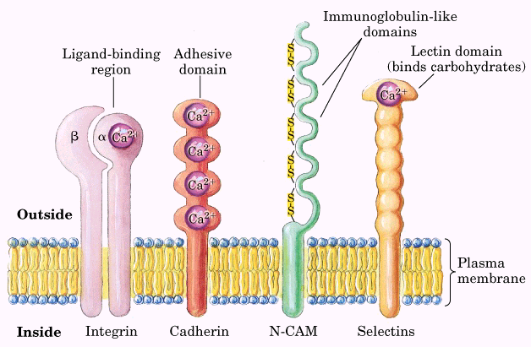 | Several families of integral proteins in the plasma membrane provide specific points of attachment between cells, or between a cell and extracellular matrix proteins. Integrins are heterodimeric proteins (with two unlike subunits, α and β) anchored to the plasma membrane by a single hydrophobic transmembrane helix in each subunit. The large extracellular domains of the α and β subunits combine to form a specific binding site for extracellular proteins such as collagen and Fibronectin. (see figures left)
Integrins are not merely adhesives; they serve as receptors and signal transducers, carrying information across the plasma membrane in both directions. Integrins regulate many processes, including platelet aggregation at the site of a wound, tissue repair, the activity of immune cells, and the invasion of tissue by a tumor.
At least three other families of plasma membrane proteins are also involved in surface adhesion. Cadherins undergo homophilic (“with same kind”) interactions with identical cadherins in an adjacent cell. Immunoglobulin-like proteins can undergo either homophilic interactions with their identical counterparts on another cell or heterophilic interactions with an integrin on a neighboring cell. Selectins have extracellular domains that, in the presence of Ca²⁺, bind specific polysaccharides on the surface of an adjacent cell. Selectins are present primarily in the various types of blood cells and in the endothelial cells that line blood vessels.

Membrane fusion is central to many biological processes
A remarkable feature of the biological membrane is its ability to undergo fusion with another membrane without losing its integrity. Although membranes are stable, they are by no means static.  Specific fusion of two membranes requires that (1) they recognize each other; (2) their surfaces become closely apposed, which required the removal of water molecules normally associated with the polar head groups of lipids; (3) their bilayer structures become locally disrupted; and (4) the two bilayers fuse to forma single continuous bilayer. Receptor-mediated endocytosis or regulated secretion also requires that (5) the fusion process is triggered at the appropriate time or in response to a specific signal. Integral proteins called fusion proteins mediate these events, bringing about specific recognition and a transient, local distortion of the bilayer structure that favors membrane fusion.  Membrane fusion is central to other cellular processes, too, such as the movement of newly synthesized membrane components through the endomembrane system from the endoplasmic reticulum through the Golgi complex to the plasma membrane via membrane vesicles, and the release of proteins, hormones, or neurotransmitters by exocytosis. The proteins required for these membrane fusions, called SNARES (synaptosome-associated protein receptors), resemble the viral fusion proteins in several respects. (see right and bottom) | 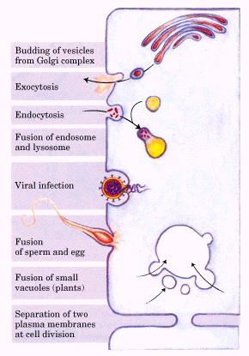

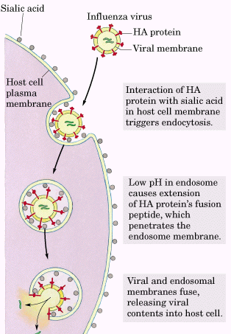 | 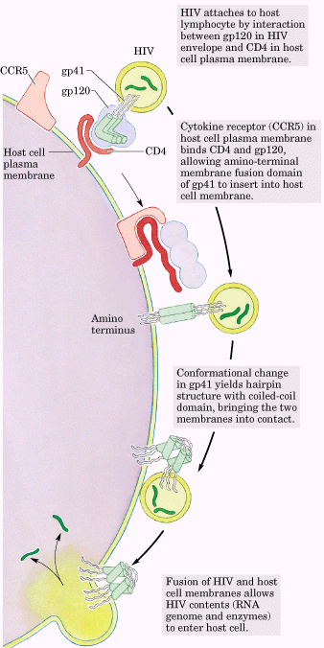

Solute transport across membranes
With few exceptions, the traffic of small molecules across the plasma membrane is mediated by proteins such as transmembrane channels, carriers, or pumps.

Passive transport is facilitated by membrane proteins
When two aqueous compartments containing unequal concentrations of a soluble compound or ion are separated by a permeable divider (membrane), the solute moves by simple diffusion from the region of higher concentration, through the membrane, to the region of lower concentration, until the two compartments have equal solute concentrations. When ions of opposite charge are separated by a permeable membrane, there is a transmembrane electrical gradient, the membrane potential, V_{m}. These two factors are referred to as the electrochemical gradient or the electrochemical potential.
In living organisms, simple diffusion of most solutes is impeded by selectively permeable barriers – membranes that separate intracellular compartment and surround cells. The energy of activation (ΔG≠) for translocation of a polar solute across the bilayer is so large that pure lipid bilayers are virtually impermeable to polar and charged species over periods of time relevant to cells.
A few biologically important gases can cross membranes by simple diffusion: molecular oxygen, nitrogen, and methane, all of which are relatively nonpolar.
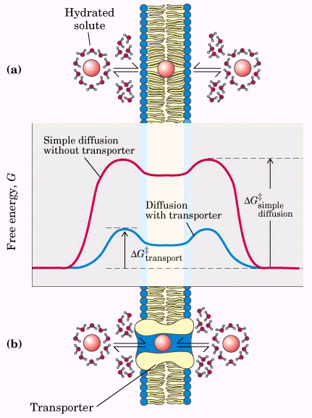 | Transmembrane passage of polar compounds and ions is made possible by membrane proteins that lower the activation energy for transport by providing an alternative path for specific solutes through the lipid bilayer. Proteins that bring about this facilitated diffusion or passive transport are not enzymes in the usual sense; their “substrates” are moved from one compartment to another; but are not chemically altered. Membrane proteins that speed the movement of a solute across a membrane by facilitating diffusion are called transporters or permeases.  Transporters span the lipid bilayer at least once, and usually several times, forming a transmembrane channel lined with hydrophilic amino acid side chains. The channel provides an alternative path for a specific substrate to move across the lipid bilayer without its having to dissolve in the bilayer; further lowering ΔG≠ for transmembrane diffusion (see figure left).
Aquaporins form hydrophilic transmembrane channels for the passage of water
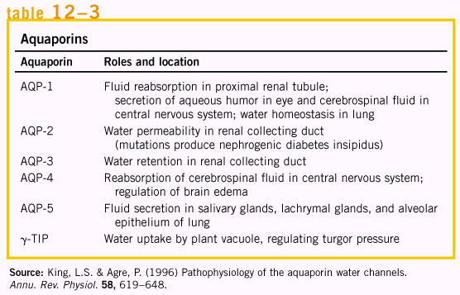 | A family of integral proteins, the aquaporins (AQPs), provide channels for rapid movement of water molecules across plasma membranes in a variety of specialized tissues. Erythrocytes, plasma membrane of proximal renal tubule cells, and the vacuolar membrane of plant cells are rich in aquaporins.  All aquaporins are type III integral proteins with six transmembrane helical segments. The low activation energy for passage of water through aquaporin channels (ΔG≠ < 15 KJ/mol) suggests that water moves through the channels in a continuous stream, flowing in the direction dictated by the osmotic gradient. A various of aquaporins are listed in table 12-3 (left).

The glucose transporter of erythrocytes mediates passive transport
The glucose transporter of erythrocytes (called GluT1 to distinguish it from related glucose transporters in other tissues) is a type III integral protein (Mr 45,000) with 12 hydrophobic segments, each of which is believed to form a membrane-spanning helix.
The process of glucose transport can be described by analogy with an enzymatic reaction in which the “substrate” is glucose outside the cell (S_{out}), the “product” is glucose inside (S_{in}), and the “enzyme” is the transporter.
According to the enzymatic kinetics, we can have the following equation.

$$V_{0}=\frac{V_{\text{max}}[S]_{\text{out}}}{K_{t}+[S]_{\text{out}}}$$
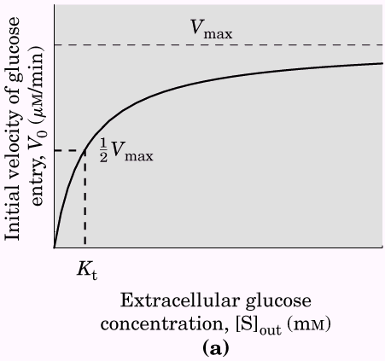 | 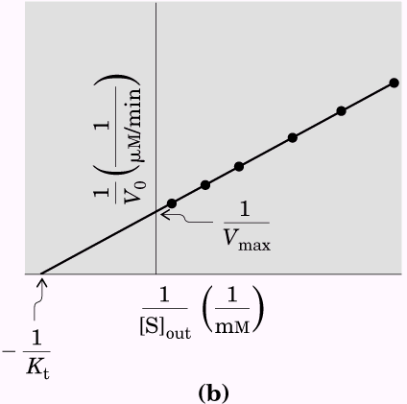 | Because no chemical bonds are made or broken in the conversion of S_{out} to S_{in}, neither “substrate” nor “product” is intrinsically more stable, and the process of entry is therefore fully reversible. As [S]_{in} approaches [S]_{out}, the rates of entry and exit become equal. GluT1 shows the three hallmarks of passive transport: high rates of diffusion down a concentration gradient, saturability, and specificity. The kinetics of glucose transport into erythrocytes are shown in left figures.

Chloride and bicarbonate are cotransported across the erythrocyte membrane
The chloride-bicarbonate exchanger, also called the anion exchange protein, increases the permeability of the erythrocyte membrane to HCO₃⁻ by a factor of more than a million. Like the glucose transporter, it is an integral protein that probably spans the membrane 12 times. This protein mediates the simultaneous movement of two anions; for each HCO₃⁻ ion that moves in one direction, one Cl⁻ ion moves in the opposite direction. The coupling
of Cl⁻ and HCO₃⁻ movement is obligatory; in the absence of chloride, bicarbonate transport stops. In this respect, the anion exchanger is typical of all systems, called cotransport systems that simultaneously carry two solutes across a membrane. When, as in this case, the two substrates move in opposite directions, the process is antiport. In symport, two substrates are moved simultaneously in the same direction. Transporters that carry only one substrate, such as the erythrocyte glucose transporter, are uniport systems. (See right pictures) | 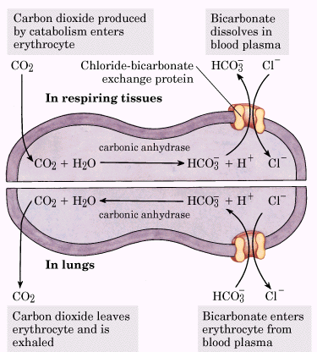 | 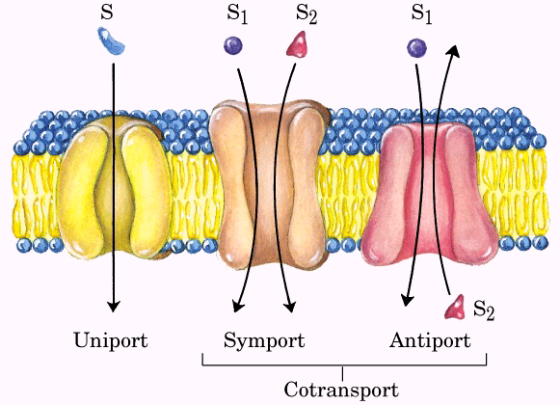

Active transport results in solute movement against a concentration or electrochemical gradient
In passive transport, the transported species always moves down its electrochemical gradient and is not accumulated above the equilibrium point. Active transport, by contrast, results in the accumulation of a solute above the equilibrium point. Active transport is thermodynamically unfavorable (endergonic) and occurs only when coupled (directly or indirectly) to an exergonic process such as the absorption of sunlight, an oxidation reaction, the breakdown of ATP, or the concomitant flow of some other chemical species down its electrochemical gradient. In primary active transport, solute accumulation is coupled directly to an exergonic chemical reaction, such as conversion of ATP to ADP + Pi. Secondary active transport occurs when endergonic (uphill) transport of one solute is coupled to the exergonic (downhill) flow of a different solute that was originally pumped uphill by primary active transport.
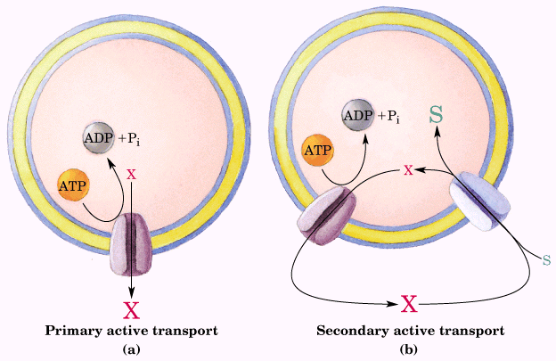 | When the solute is an ion, its movement without an accompanying counterion results in the endergonic separation of positive and negative charges, producing an electrical potential; such a transport process is said to be electrogenic. The energetic cost of moving an ion depends on the electrochemical potential, the sum of the chemical electrical gradients: ΔG_{t} = RTln (C₂/C₁) + ZF Δψ  Where Z is the charge on the ion, F is the Faraday constant (96,480 J/V.mol), and Δψ is the transmembrane electrical potential (in volts). For many cells and tissues, active transport is therefore a major energy-consuming process.

There are at least four general types of transport ATPases
In the course of evolution, several distinct types of ATP-dependent active transporters have arisen, differing in structure, mechanism, and localization in specific tissues and intracellular compartments.
P-type ATPases are ATP-driven cation transporters that are reversibly phosphorylated by ATP as part of the transport cycle. All P-type transport ATPases have similarities in amino acid sequence, especially near the Asp residue that undergoes phosphorylation, and all are sensitive to inhibition by the phosphate analog vanadate. Each is an integral protein with multiple membrane-spanning regions in a single polypeptide; very widely distributed.
A distinctly different class of proton-transporting ATPases is responsible for acidifying intracellular compartments in many organisms. The vacuoles of fungi and higher plants maintain a pH between 3 and 6, well below that of the surrounding cytosol (pH 7.5), by the action of V-type ATPases ---proton pumps. V-type ATPases (V for vacuolar) are also responsible for the acidification of lysosomes, endosomes, the Golgi complex, and secretory vesicles in animal cells. All V-type ATPases have a similar complex structure, with an integral (transmembrane) domain (V₀) that serves as a proton channel and a peripheral domain (V₁) that contains the ATP-binding site and the ATPase activity.
F-type ATPases play a central role in energy-conserving reactions in bacteria, mitochondria, and chloroplasts (The F in their name originated in their identification as energy-coupling factors). They catalyze the uphill transmembrane passage of protons driven by ATP hydrolysis, as well as the reverse reaction, in which downhill proton flow drives ATP synthesis. In the second case, the F-type ATPases are more appropriately name ATP syntheases.
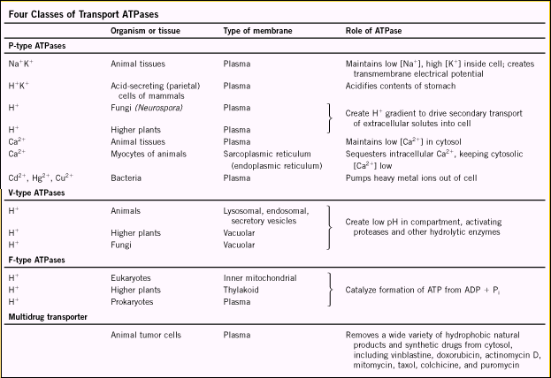 | The plasma membranes of tumors contain an ATP-dependent transporter that can export many different drugs, preventing their accumulation within the tumor cells and their growth-inhibitory effects. The transported drugs are chemically dissimilar but are generally hydrophobic. The multidrug transporter responsible for removing these drugs from the tumor cell cytosol is an integral protein (Mr 170,000) with 12 transmembrane segments and two ATP-binding sites. Export of the drugs is driven by ATP hydrolysis.

A P-type ATPase catalyzes active cotransport of Na+ and K+
In virtually every animal cell, the concentration of Na⁺ is lower in the cell than in the surrounding medium, and the concentration of K⁺ is higher. This imbalance is established and maintained by a primary active transport
system in the plasma membrane. The enzyme Na⁺K⁺ ATPase, couples breakdown of ATP to the simultaneous movement of both Na⁺ and K⁺ against their electrochemical gradients. For each molecule of ATP converted to ADP and Pi, the transporter moves two K⁺ ions inward and three Na⁺ ions outward across the plasma membrane. The Na⁺K⁺ ATPase is an integral protein with two subunits (Mr ~ 50,000 and ~110,000), both of which span the membrane.  The model of which ATPase cycles between two forms, a phosphorylated form (designated P-Enz_{II}) with high affinity for K⁺ and low affinity for Na⁺, and a dephosphorylated form (Enz_{I}) with high affinity for Na⁺ and low affinity for K⁺ can explain the mechanism for the transportation of Na⁺ and K⁺.  The central role of the Na⁺K⁺ ATPase is reflected in the energy invested in this single reaction: about 25% of the total energy consumption of a human at rest! | 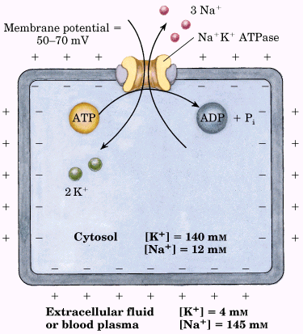

ATP-Driven Ca²⁺ pumps maintain a low concentration of calcium in the cytosol
The cytosolic concentration of free Ca²⁺ is generally about 100 nM (why?). Calcium ions are pumped out of the cytosol by a P-type ATPase, the plasma membrane Ca²⁺ pump. Another P-type Ca²⁺ pump in the endoplasmic reticulum moves Ca²⁺ into the ER lumen, a compartment separate from the cytosol.
The plasma membrane Ca²⁺ pump and SERCA pumps (the sarcoplasmic and endoplasmic reticulum calcium) are integral proteins that cycle between two conformations in a mechanism similar to that for Na⁺K⁺ ATPase.

Ion gradients provide the energy for secondary active transport
The ion gradients formed by primary transport of Na⁺ or H⁺ can themselves provide the driving force for cotransport of other solutes. Many cells contain transport systems that couple the spontaneous, downhill flow of these ions to the simultaneous uphill pumping of another ion, sugar, or amino acid.
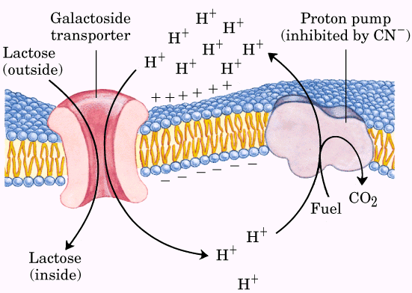 | 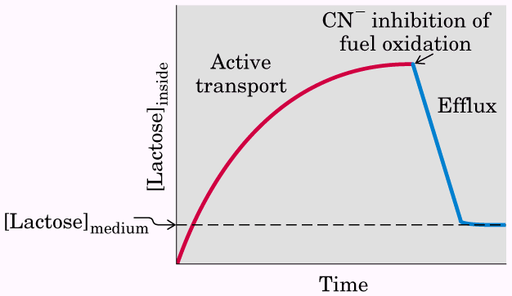 | In intestinal epithelial cells, glucose and certain amino acids are accumulated by symport with Na⁺, using the Na⁺ gradient established by the Na⁺K⁺ ATPase of the plasma membrane.

The energy required for this process comes from two sources: the greater concentration of Na⁺ outside than inside (the chemical potential) and the transmembrane potential (the electrical potential), which is inside-negative and therefore draws Na⁺ inward.  The cotransporter can pump glucose inward until its concentration | 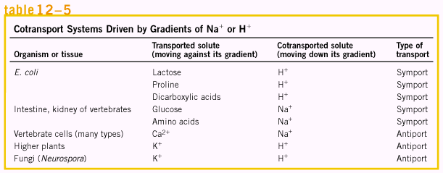

within the epithelial cell is about 30,000 times that in the intestine. As glucose is pumped from the intestine into the epithelial cell at the apical surface, it is simultaneously moved from the cell into the blood by passive transport through a glucose transporter (GluT2) in the basal surface. The crucial role of Na⁺ in symport and antiport systems such as these requires the continued outward pumping of Na⁺ to maintain the transmembrane Na⁺ gradient.
Because of the essential role of ion gradients in active transport and energy conservation, compounds that collapse the ion gradients across cellular membranes are poisons, and those that are specific for infectious microorganisms can serve as antibiotics. Compounds that shuttle ions across membranes in this way are called ionophores, literally “ion bearers”.

Ion-selective channels allow rapid movement of ions across membranes
The ion-selective channel is another mechanism for moving inorganic ions across membranes. Ion channels determine the plasma membrane’s permeability to specific ions and, together with ion pumps such as the Na⁺K⁺ ATPase, regulate the cytosolic concentration of ions and the membrane potential.
Ion channels are distinguished from ion transporters in at least three ways. First, the rate of flux through channels can be orders of magnitude greater than the turnover number for a transporter 10⁷ to 10⁸ ions per channel per second, near the theoretical maximum rate for unrestricted diffusion. Second, ion channels are not saturable; their rates do not approach a maximum at high substrate concentration. Third, they are “gated”---opened or closed in response to some cellular event. In ligand-gated channels (which are generally oligomeric), binding of some extracellular or intracellular small molecule forces an allosteric transition in the protein, which opens or closes the channel. In voltage-gated ion channels, a charged protein domain moves relative to the membrane in response to a change in transmembrane electrical potential, causing the ion channel to open or close. Gating by either ligands or membrane potential can be very fast. A channel typically opens in a fraction of a millisecond, and may remain open for only milliseconds, making these molecular devices effective for very fast signal transmission in the nervous system.

The structure of a K⁺ channel shows the basis for its ion specificity
Both the ion specificity and the high flux through the channel of potassium channel are understandable from the channel’s structure. At the inner and outer plasma membrane surfaces, the entryways to the channel have several negatively charged amino acid residues, which presumably increase the local concentration of cations such as K⁺ and Na⁺. The ion path through the membrane begins (on the inner surface) as a wide, water-filled channel in which the ion can retain its hydration sphere. Further stabilization is provided by the short α helices in the pore region of each subunit, with their carboxyl termini and the associated partial negative charges pointed at K⁺ in the channel. Other K⁺ channels are similar in sequence, and presumably in structure and mechanism, to the S. lividan K⁺ channel.

The acetylcholine receptor is a ligand-gated ion channel
Nicotinic acetylcholine receptor, which is essential in the passage of an electrical signal from a motor neuron to a muscle fiber at the neuromuscular junction (signaling the muscle to contract). (nicotinic receptors were originally distinguished from muscarinic receptors by the sensitivity of the former to nicotine, the latter to the mushroom alkaloid muscarine). The acetylcholine receptor allows Na⁺, Ca²⁺, and K⁺ to pass through with equal ease, but other cations and all anions are unable to pass.
This receptor channel is typical of many other ion channels that produce or respond to electrical signals: it has a “gate” that opens in response to stimulation by acetylcholine, and an intrinsic timing mechanism that closes the gate after a split second. Thus the acetylcholine signal is transient – an essential feature of electrical signal conduction.
The nicotinic acetylcholine receptor is composed of five subunits: single copies of subunits β, γ, and δ, and two identical α subunits each with an acetylcholine-binding site. All five subunits are related in sequence and tertiary structure, each having four transmembrane helical segments (M₁ to M₄). The five subunits surround a central pore, which is lined with their M₂ helices.
Based on similarities between the amino acid sequences of other ligand-gated ion channels and the acetylcholine receptor, the receptor channels that respond to the extracellular signals γ-aminobutyric acid (GABA), glycine, and serotonin are classified in an acetylcholine receptor superfamily and probably share three-dimensional structure and gating mechanisms. GABA_{A} and glycine receptors are anion channels specific for Cl⁻ and HCO₃⁻, whereas the serotonin receptor, like the acetylcholine receptor, is cation-specific.
A second class of ligand-gated ion channels responds to intracellular ligands: 3’,5’-cyclic guanosine mononucleotide (cGMP) in the vertebrate eye, cGMP and cAMP in olfactory neurons, and ATP and inositol 1,4,5-triphosphate (IP₃) in many cell types. These channels are composed of multiple subunits, each with six transmembrane helical domains.

The neuronal Na⁺ channel is a voltage-gated ion channel
Na⁺ channels in the plasma membranes of neurons and of myocytes of heart and skeletal muscle sense electrical gradients across the membrane and respond by opening or closing. These voltage-gated ion channels are typically very selective for Na⁺ over other monovalent or divalent cations and have a very high flux rate. Activation followed by inactivation of Na+ channels is the basis for signaling by neurons.
The essential component of Na⁺ channels is a single, large polypeptide (1,840 amino acid residues) organized into four domains clustered around a central channel, providing a path for Na⁺ through the membrane. That path is made Na⁺-specific by a “pore region” composed of the segments between transmembrane helices 5 and 6 of each domain, which fold into the channel. Inactivation of the channel is believed to occur by a ball-and-chain mechanism.

Defective ion channels can have striking physiological consequences
Naturally occurring toxins often act on ion channels, and the potency of these toxins further illustrates the importance of normal ion channel function. Tetrodotoxin and saxitoxin are poisons that act by binding to the voltage-gated Na⁺ channels of neurons and preventing normal action potentials.

Porins are transmembrane channels for small molecules
In the outer membrane of gram-negative bacteria such as E. coli, protein channels called porins allow the passage of molecules much larger than ions, but by a mechanism more like a gated channel than a transporter.

The structure of membrane and ion transporters are summarized as below

